
CY 104L– Introduction to Cybersecurity
lab # 05
Browser Security

BS ESS – F26 – 1A
––
Student Name: Athar Imran
Student ID: 2604277

Assignment Date: 06 October, 2026
Assignment done: 06 October, 2026
Due Date: 06 October, 2026

Chrome Security

Block Third-Party Cookies
Blocking 3rd-party cookies disallows unrelated websites from tracking our activities and limits exposure to third-party cookie abuse.
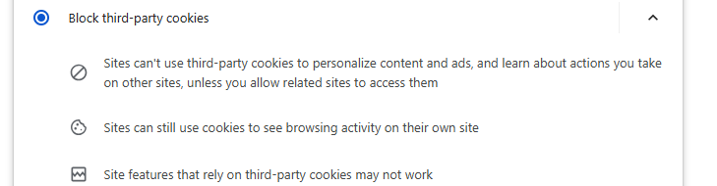

Do Not Track
Bans websites from tracking browser activities.
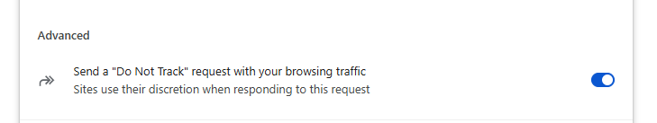

Clear Browsing Data
Deletes residual private information stored locally. Use this especially on shared or public computers.
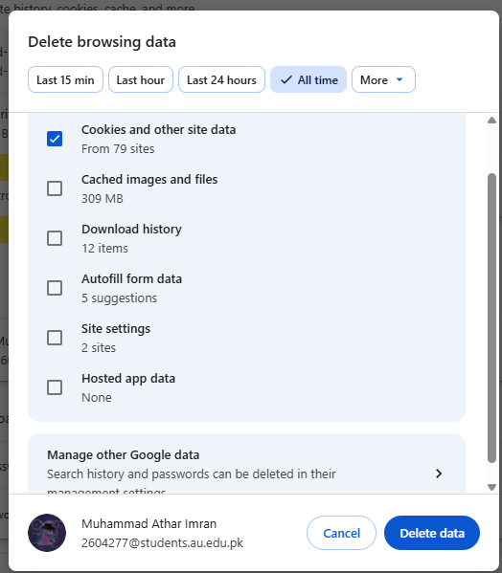

HTTPS-Only / Always Secure Connections
It prevents HTTP connections & decreases exposure to MitM attacks and tampering on insecure connections.
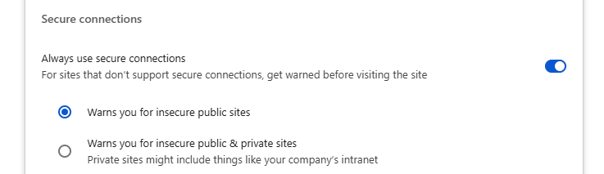

Certificate Management
It allows inspection & management of certificates, and it is used to establish trusted secure connections.
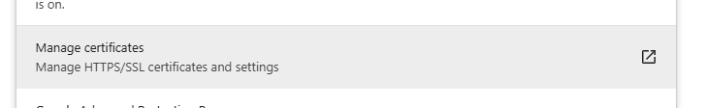

Pop-ups and Redirects
It prevents malicious pop-ups & redirects that lead to deceptive and malicious pages.
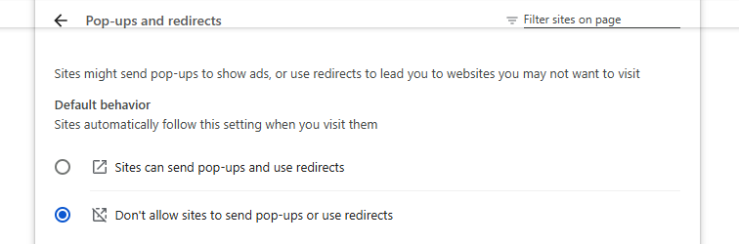

JavaScript
As, the manual note JavaScript is used to perform XSS attacks, thus, disabling it limits potentially risky active content.
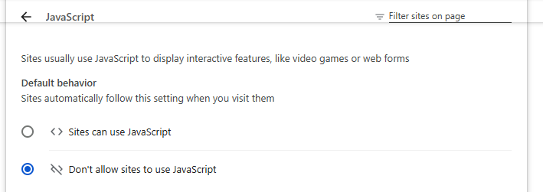

Camera and Microphone
For personal security, we must restrict websites from accessing audio/video input without our permission.
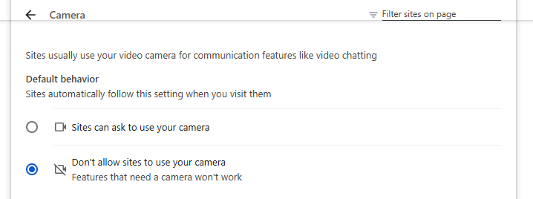

Location
Also, we must limit websites to obtain our device's location.
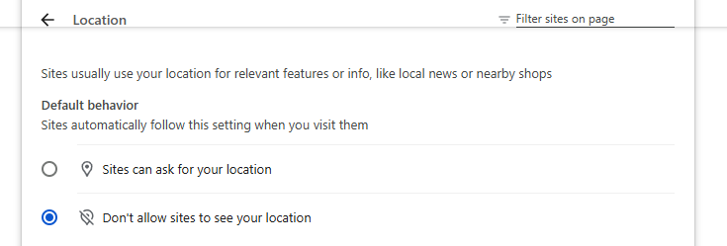

Notifications
Unwanted website notifications can be disallowed.
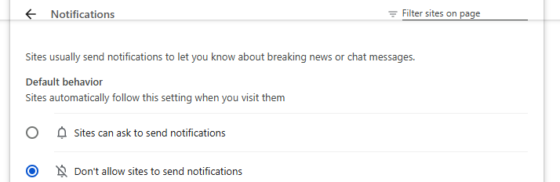

Dangerous Download Protection / Safe Browsing
It helps protect against dangerous downloads and also against dangerous & fake websites and other browsing threats.
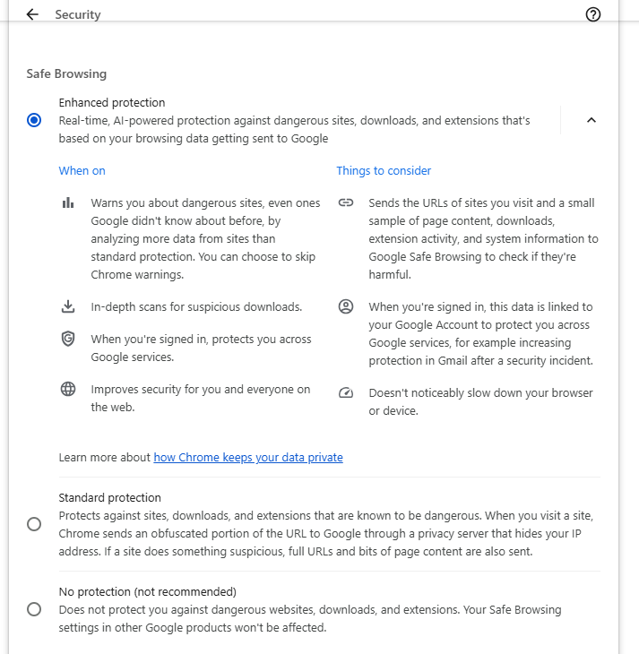

Extension Permissions
One must identify and control extensions that may have extra access to one's browsing data.
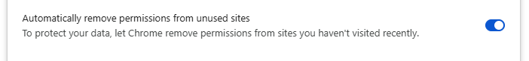

Search Engine
Use trusted search engines.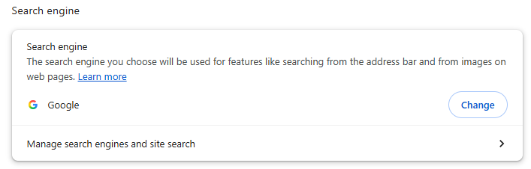

Automatic Updates
Keep the browser updated. It helps in receiving security fixes for known vulnerabilities.
